Ariel M. Bayer 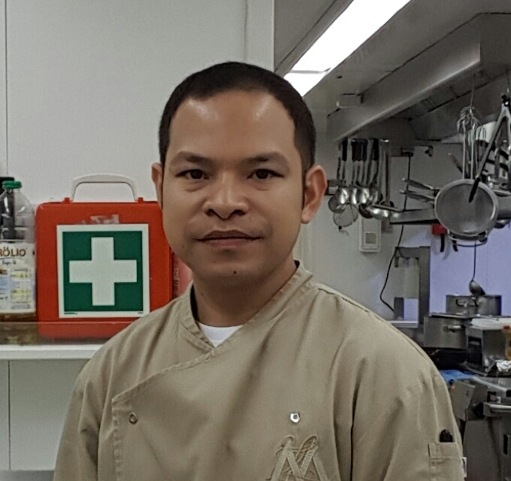
+63-908-617-5790

PERSONAL INFORMATION:
Sex: Male
Date of Birth: September 25, 1976
Marital Status: Married
Mailing Address: Blk. 19 Lot 6 Madrid St. Metro Clark,
Mawaque Mabalacat City, Pampanga,
Philippines
E-mail Address: arielbayermags@gmail.com
POSITION APPLIED FOR:
Chef/Cook
WORKING EXPERIENCE:
February 15, 2014 - up to present M/Y Lady Moura
Owners Chef
February 28, 2013 - November 28, 2013 M/Y Lady Moura
European Officers Cook

February 28, 2012 - November 28, 2012 M/Y Lady Moura
Asian Crew Cook
February 28, 2010 - November 28, 2011 M/Y Lady Moura
Asian Crew Cook
TRAININGS/CERTIFICATES:
Basic Training
Regulation VI/1, Section A-VI/1, Paragraph 2 of the STCW 1978 Convention
Issue on: January 14, 2014

Ships Security Awareness Training And Seafarers With Designated Security
Duties
ISPS Code and Chapter XI-2 of SOLAS as amended
Issue on: December 11, 2013

Crowd Management
Regulation V/2 and V/3 of the 1978 STCW Convention
Issue on: January 29, 2014

Proficiency in Crisis Management
Regulation V/2 and V/3 of the 1978 STCW Convention
Issue on: January 17, 2014

ANTI-PIRACY AWARENESS Training
As per module approved by POEA
Issue on: February 09, 2011

Marine Cooking Course
Issue on: January 13, 2017

National Certificate II
SHIPS' CATERING SERVICES ( SHIPS' COOK)
Issue on: January 21, 2014
Valid until: January 21, 2019

National Certificate III
SHIPS' CATERING ( SHIPS' COOKS)
Issue on: January 06, 2017
Valid until: January 05, 2022

Food Handling And Hygiene
Issue on: January 06, 2017

Catering On Board Ship
Issue on: January 06, 2017

Shipshape: A Guide to Good Housekeeping
Issue on: January 06, 2017

Food Safety At Sea, Personal Hygiene
Issue on: January 06, 2017

Hygiene Management and Best-Hygiene-Practice
The following subjects were handled:
Food law and standards
Infection protection act
Personnel hygiene
Food hygiene
Hygiene of building and facilities
Specific hazards, pre-requisite programs
Practice exercises
Issue on: August 01, 2015
Monte Carlo, Monaco

