BRYAN B. BUENO 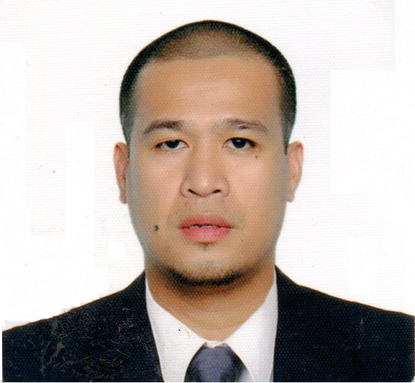
#174 A.B. Fernandez West
Dagupan City, Pangasinan 2400, Philippines
Cell # 0908 975 7548 / 0916 792 6757
bryanb1ub@yahoo.com

Career Objective :

To serve the company in a position that would best fit my qualification and to be part of the company’s growth and development that will enable contribute my skills, promote my professional development and carrer growth.

Work Experience :

MOOG CONTROL CORPORATION
PHILIPPINES
Loakan Baguio City
Gear Shop Machinist III
( September 2012 - Present )

- Perform a comlete range of operations on assigned Phasing and auxiliary machines
- Make all types of set-ups including fixture alignment and setting of tools.
- Does program Dry Run and Adjustments
- Perform statiscally controlled operations / processes.
- Recognize necessary adjustments on cutting parameters and coordinates with support for disposition.
- Detect defective parts and toolings and notifies Cluster Leader and Engineering support of unusual conditions.
- Assist support groups in prove-outs and other developmental projects.
- Support in Product Quality activities.
- Load parts program
- Inspects and presets tools.
- Installs and tests coolant potion, leve, concentration.
- Monitors tools performance and life.
Tool geometry
Tool touching
- Performs why why analysis and provide corrective action on non onforming parts
- Perform touch setter/probe calibration and touching
- Use and interpret Zeiss result
- Privide assistance and guidance for Machinists 1.

- Machine operated:
OKUMA LT300-M LATHE
OKUMA LU-300M
OKUMA MXVA MILLS
OKUMA 10 PALLET
MILLING
GLEASON HOBBER
GLEASON 280C BEVEL
CUTTING

LEEWAH INDUSTRY COMPANY
KOREA
MACHINE OPERATOR
RICE POLISHING MACHINE PRODUCTION
(October 2009 – August 2012)

- Operating AMADA RD-18 Bending Machine and Murata Wiedman 2458 Punching Machine.
- Setting and preparing of the machine
- Receiving datas and specifications of the steel to be bend.
- Changing the punches and dies of the machine.
- Inputing the details of the steel to be bend to a certain angle and length using the amada multimedia network controler computer.
- Measuring the thickness of the steel using caliper and protractor for the bended angle of the steel.
- Checking the allowable pressure between the machine and the steel.
- Checking the output using AUTOCAD.

DAEBO HWA-SEOM CO.
KOREA
TEXTILE
FORKLIFT OPERATOR
(2005 - 2009)

- Receiving raw materials of the textile product.
- Arranging the raw materials and the product to the stockroom.

Education : TECHNICAL EDUCATION & SKILLS DEVELOPMENT AUTHORITY
Loakan Baguio City
March 2012 - September 2012
General Machine Shop
Lathe - National Certificate II
Mills - National Certificate II
Grinds - National Certificate II

College University of Baguio
Baguio City
Civil Engineering
1997 - 2002
Secondary Reina Mercedez Vocational and Industrial School
Reina Mercedez, Isabela
1993 -1997
Elementary Linglingay Elementary School
Gamu, Isabela
1987 - 1993

Personal Data : Age 38
Birth Date February 24, 1980
Civil status Married
Height 5’10”
Citizenship Filipino
Religion Roman Catholic
Dialects Spoken Ilocano, English, Filipino&Korean

CHARACTER REFERENCES

RINGO MILO
Manufacturing Manager
Moog Control Corp. Philippines
+639178088268

ENGR. GERALD LAMBINO
Mechanical Engineer Gear Department
Moog Control Corp. Philippines
+639176306631

FELICIANO SANTOS
USITECH2000
Machinist
418-580-6600

I hereby certify the the above information is true and correct to the best of my knowledge.

Bryan B. Bueno
Applicant

