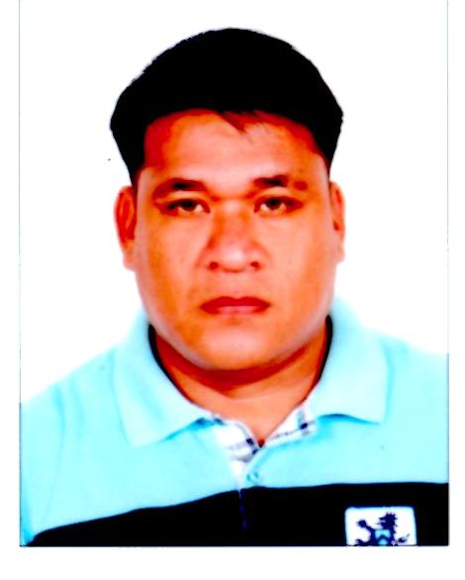
CHRISTOPHER AGUILAR AGNE
agne_christopher@yahoo.com
P.O Box 129920 / Plot 6&7 AR 17 ICAD 2 Mussafah Industrial Area,
ABU DHABI. UAE
Mobile # +971502973582 / +971507124277

___________________________________________________________________
Job Objectives:
To land in a Job where my leadership skill is fully required and my well-roundedness and innate interpersonal skill will benefit the company and that I am going to work with. To apply for an entry level position commensurate to my qualification; to utilize my knowledge and skills to gain valuable experience; to have a responsible position requiring my skills and abilities.
POSITION DESIRED:

- ASSISTANT TERMINAL OPERATOR
- ASSISTANT PLANT MAINTENANCE
- MACHINE OPERATOR
- FORKLIFT OPERATOR with Valid ( FORKLIFT DRIVING LICENSE )

EMPLOYMENT RECORD:

National Oilwell Varco Tuboscope Wellbore Technologies.
P.O Box 129920 / Plot 6&7 AR 17 ICAD 2 Mussafah Industrial Area, Abu Dhabi, U.A.E.
January 2015- March 2016. (Cancelled)

- FORKLIFT OPERATOR
- OVERALL YARD INSPECTOR

Duties and Responsibilities:

- Receives items for shipment, inspects visually for identity, quantity, and condition. Checks for obvious damage and segregates items requiring special handling.
- Loads and unloads materials onto or from pallets, trays, racks and shelves by hand or with forklift or other handling equipment.
- Loads materials into carrier vehicles and installs strapping, bracing or logistic bars padding to prevent shifting or damage in transit.
- In charge of supervising in terms of safety, maintenance and loading and offloading of pallets, pipes and deliveries and other related works with regards to fork lifting.

Emirates National Oil Company - ELOMP, Fujairah
P.O. Box #4037, Fujairah, U.A.E.
October 2009 –December 5, 2012 (Finished Contract)

- ASSISTANT PLANT MAINTENANCE / FORKLIFT OPERATOR

Duties and Responsibilities (Assistant Plant Maintenance):

- Assists the Plant Maintenance Officer who conducts maintenance for all mechanical, electrical equipments.
- Checks equipments and areas to ensure ordered temperature/pressures/level rates and other operational variables are maintained and that equipments are effectively utilized.
- Inspects, lubricates, greases, maintains oil levels and drains water from utility reservoirs.
- Carries out “Preventive Maintenance”, painting and other work as required for upkeep and general housekeeping.
- Conducting maintenance of pump motors and forklift motors (2.5 tons), and assist in aligning motors.
- Ensuring proper line up when there is an oil movement
- Monitoring Pumps parameters while on operation
- Operates diesel generators and heater
- Takes manual measurements of tank stocks, draws, delivers and disposes samples from the laboratory, vents/drains lines, drains water from.

Duties and Responsibilities (Forklift Operator):

- Operates 2.5 ton to 3.0 ton forklift machine
- Loads and unloads drums of oil onto or from pallets.
- Loads materials into carrier vehicles and installs strapping, bracing or logistic bars padding to prevent shifting or damage in transit.
- Manually move freight, stock, or other materials.
- Moves levers and presses pedals to drive truck and control movement of lifting apparatus.

Fujairah International Airport
P.O. Box #977, Fujairah, U.A.E.
October 2006 –October 2009

- CARGO HANDLER
- FORKLIFT OPERATOR

Duties and Responsibilities: (Cargo Handler)

- Receives items for shipment, inspects visually for identity, quantity, and condition. Checks for obvious damage and segregates items requiring special handling.
- Loads and unloads materials onto or from pallets, trays, racks and shelves by hand or with forklift or other handling equipment.
- Loads materials into carrier vehicles and installs strapping, bracing or logistic bars padding to prevent shifting or damage in transit.
- Completes receiving and shipping documents accurately and completely per Pro trans specifications with the scan gun.
- Ensures proper identification. Identifies all shipments by proper marking and labeling, including special handling instructions.
- Coordinates transportation requirements.
- Warehouses and stores inbound and outbound cargo awaiting processing and/or onward movement. Stacks or assembles materials into bundles and bands bundles together as direct per work instructions.

Duties and Responsibilities: (Forklift Operator)

- Operates 3 ton and 7 ton Forklift Machine, Tractor, Conveyor belt machine and 1.5 ton electric Forklift machine.
- Manually move freight, stock, or other materials.
- Moves levers and presses pedals to drive truck and control movement of lifting apparatus.
- Positions forks, lifting platform, or other lifting device under, over, or around loaded pallets skids, boxes, products, or materials and transports load to designated area.
- Unloads and stacks material by raising and lowering lifting device.
- Perform materials inventories on work floor, and supply workers with materials as needed.
- Weighs materials or products and records weight on tags, labels, or production schedules.
- Loads or unloads materials onto or off of pallets, skids, or lifting device.
- Lubricates truck, recharges batteries, fills fuel tank, or replaces gas tank.
- Other duties may be assigned.

International Wiring System Phils. Corporation
LIPSEPZ, San Miguel, Tarlac City, Philippines
September 1994 – September 2004

- WAREHOUSEMAN
- FORKLIFT OPERATOR
- MACHINE OPERATOR
- IMPROVEMENT PLANT MAINTENANCE

Duties and Responsibilities: (Warehouse Man)

The Warehouse Man oversees all aspects of the warehouse. Plans, organizes, and monitors the receiving, storage, and distribution of all product received either from suppliers or production shop to effectively and efficiently meet internal and external customer requirements. Supervises all warehouse staff, including hiring, training, scheduling and performance management. Makes suggestions for the improvement of plant production.

TRAINING ATTENDED:

Safety Forklift Training
Conducted by : EURO GULF SAFETY CONSULTANT
Date : November 20, 2015
Place of training : NOV-TUBOSCOPE, ICAD-2 Mussafah Industrial Aria, Abu Dhabi, U.A.E.

Fire Fighting and Basic Safety Training
Conducted by : EURO GULFT SAFETY CONSULTANT
Date : March 16, 2015
Place of training : PO Box 35710, Mussafah Abu Dhabi, U.A.E.

Safety Forklift Training
Conducted by : ENOC Company
Date : January 27, 2011
Place of training : ELOMP Compound, Seaport Fujairah, U.A.E.

EDUCATIONAL BACKGROUND:

Tertiary: Citizens Polytechnic Institute
F. Tañedo St., Tarlac City, Philippines
June 1989 – March 1990
Course- AUTO DIESEL MECHANIC

Secondary: Tarlac National High School
San Miguel, Tarlac City, Philippines
June 1984 – March 1988

PERSONAL PROFILE:

Age : 44 years old
Sex : Male
Date of Birth : September 29, 1971
Place of Birth : Tarlac City, Philippines
Civil Status : Married
Religion : Roman Catholic
Height : 5’4”
Nationality : Filipino
Passport No. : EB 7509934
Date Issued : February 13, 2013
Place of Issue : Philippines Consulate Dubai, U.A.E.
VISA STATUS : Employment Visa

SPECIAL SKILLS:

- PLANT MAINTENANCE
- FORKLIFT OPERATOR
- WAREHOUSEMAN
- MACHINE OPERATOR

Reference:
Upon Request.

CHRISTOPHER A. AGNE

