# CHRISTOPHER M. DACO

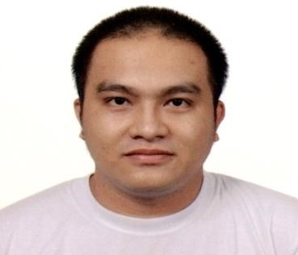

Lot 11, Block 1 St. Michael Ville Callejon 2

Brgy. Sta. Cruz, Pasig City

(+63) 919-486-0271/ (+63) 915-910-2863

cris.daco@yahoo.com

## JOB OBJECTIVE:

In search of a job/position where my skills and work experiences for 8 years as a factory worker will be fully utilized in the growth of a company.

## KEY STRENGTHS

* Excellent experience in food handling and its sanitation requirements.
* 8 years of experience in the operation of the manufacturing equipment and safety.
* Possess good communication and writing skills.
* Able to communicate positively and a team player.
* Able to work under pressure with minimal supervision.

## WORK EXPERIENCE

# AKO, IKAW MAY-ARI NG KOOPERATIBA (AIMKO)

Machine helper/Materials Handler

Universal Robina Corporation (URC) – Chocolate Plant

June 2010- present

Pasig City, Philippines

* Responsible in setting product codes to each final product which contains the necessary information of the product
* Ensures that the vertical seals of the packaging are tightened and aligned in the equipment
* Ensures the cleanliness of machine cutter is properly maintained
* Responsible in monitoring the temperature of the machine and ensures that the raw materials needed in the process area are delivered
* Responsible in the daily inventory of raw and packaging materials needed in the production

# KADAMAY MANPOWER SERVICES

Palletizer

Universal Robina Corporation (URC) – Wafer Plant

November 2008 - April 2009

Pasig City, Philippines

* Assures final packed products are properly weight and correctly tallied
* Ensures final products expiration dates are accurately labeled
* Responsible in reporting the total numbers of output/product produced and ensures that the products complied with the standards
* Assure that the final products are properly stocked in an orderly manner as per manufacturing date requirement.

## EDUCATIONAL BACKGROUND

|  |  |  |  |
| --- | --- | --- | --- |
| *Tertiary Level* |  |  | *Bachelor of Science in Office*  *Administration- Major in Office Management*  Undergraduate  PARTIDO STATE UNIVERSITY  Goa, Camarines Sur, Philippines  2004 |
| *Secondary Level* |  |  | GOA NATIONAL HIGH SCHOOL  *Goa, Camarines Sur, Philippines*  *2000 – 2004* |
| *Elementary Level* |  |  | GOA CENTRAL SCHOOL  *Goa, Camarines Sur, Philippines*  *1994– 2000* |

## PERSONAL DATA

|  |  |  |
| --- | --- | --- |
| Age |  | : 30 years old |
| Sex |  | : Male |
| Height |  | : 5’ 5” |
| Weight |  | : 169 lbs. (77 kg) |
| Civil Status |  | : Married |
| Birth date |  | : September 29, 1987 |
| Language |  | : Tagalog, English |

## CHARACTER REFERENCES

# ROGER POTUTAN

Production Supervisor

UNIVERSAL ROBINA CORPORATION

Bagong Ilog, Pasig City

(+63) 920-966-9438/ (+63) 917-680-0613

# ALDIN JUNIO

Production Manager

UNIVERSAL ROBINA CORPORATION

Rosario, Pasig City

(+63) 922-814-5157

I hereby attest the above aforementioned are true and correct.

# CHRISTOPHER M. DACO

Applicant