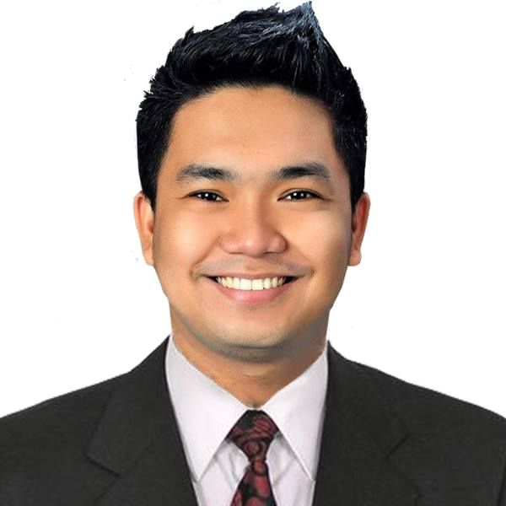
Cristian Paul M. De Guzman
402 A. Mabini St., Sabang, Baliuag, Bulacan, Philippines 3006
(+63) 942-165-0528
cristianpauldeguzman@yahoo.com

TEACHING QUALIFICATIONS:
- Tremendous teaching passion and wide exposure to different aspects of the job profile
- Uncommon teaching aptitude and a great affection for all related job duties
- Great concern regarding the students difficulties, both academic as well as personal
- A great problem solving attitude and ability to counsel students in overcoming their educational obstacles
- Adequate knowledge of all the modern teaching aids and ability to apply them effectively
EDUCATIONAL BACKGROUND:

GRADUATE 2012 - 2014
Master of Arts in Education – Major in Language Education
(Academic Requirements Completed)
Bulacan State University – Malolos Campus
City of Malolos, Bulacan

TERTIARY 2007 - 2011
Bachelor of Secondary Education – Major in English
Bulacan State University – Bustos Campus
Poblacion, Bustos, Bulacan

SECONDARY 2003 - 2007
San Rafael National Trade School
Caingin, San Rafael. Bulacan

PRIMARY 1997 - 2003
Sabang Elementary School
Sabang, Baliuag, Bulacan

TEACHING EXPERIENCE:
- ST. MARY’S COLLEGE OF BALIUAG
ISO 9001-2008 Certified
PAASCU Level III Accredited
- Head, Basic Education English Department 2017 – Present
    - Assists and monitors teachers in the delivery
of instruction in the English Area
- Part-Time College Language Instructor 2015 – Present
- Teaches specific major subjects in the
General Education program
- Junior High School Language Teacher 2011 – Present
    - Delivers instruction that is well-planned
on a daily basis
- Senior High School Language Teacher 2016 – 2017
    - Delivers instruction that is well-planned
on a daily basis.
- Homeroom Adviser 2011 – 2016
    - Takes charge of the entire class in all their
needs in school
- School Paper Adviser, The Marynette 2015 – 2017
- Advises and instructs the staffers in issuing
the school paper
- Club Moderator, Debate Society 2012 – 2015
    - Facilitates club activities specifically debate

- PRACTICE TEACHER
- Carlos F. Gonzales High School 2010 – 2011
- Assisted the homeroom teacher in the
delivery of discussion of lesson
- San Rafael National Trade School 2010 – 2011
- Assisted the homeroom teacher in the
delivery of discussion of lesson

ACHIEVEMENTS:
- Licensure Examination for Teachers (LET) Board Passer
September 2011
- Perfect Attendance Awardee (Hall of Famer)
2014, 2015, 2016, 2017
- Top 3, Faculty Efficiency Rating (SY: 2013-2014)
- Recipient, Verbal-Linguistic Intelligence Award for Faculty
SY: 2014-2015
- Most Efficient English Teacher, English Area
SY: 2015-2016, SY: 2016-2017, SY: 2017-2018
- Creative Storytelling Teacher’s Category
-Champion, District Level
-4th Placer, Provincial Level
- Winning Coach of High School Elocution and Debate Competitions
District and Provincial Levels
- Winning Coach of Secondary Schools Press Conference (Campus Journalism)
Division and Regional Levels across all Writing Categories
- Outstanding Pre-Service Teacher (Senior Category)
BSU – Bustos Campus Practice Teaching

ACADEMIC AFFILIATIONS:
- Association for Supervision and Curriculum Development 2015 - Present
(ASCD) Organization
- Regional Association of Elementary 2016-2017
and Secondary School Paper Adviser (RAESSPA)
- Society of Future Educators, CoEd 2008-2011

ACADEMIC SEMINARS/TRAININGS ATTENDED:
- Leadership on Performance Management November 2017
Baliuag, Bulacan, Philippines
- The Art of Questioning and Discussion Techniques June 2017
Baliuag, Bulacan, Philippines
- Symposium on Senior High School Content Mastery February 2017
Angeles City, Pampanga, Philippines
- 2015 Training for Senior High School May 2015
St. Scholastica’s Academy, Pampanga, Philippines
- Professional and Work Ethics January 2015
Baliuag, Bulacan, Philippines
- Skills on Basic Counseling and Facilitating November 2013
Homeroom Activities
Baliuag, Bulacan, Philippines
- Seminar-Workshop on Research Skills October 2013
Baliuag, Bulacan, Philippines
- Seminar on Effective Innovative Recruitment August 2011
and Marketing Strategies
Baliuag, Bulacan, Philippines

REFERENCES:

- Mrs. Mercedita Dungo
IBEd Academic Cordinator, St. Mary’s College of Baliuag
Poblacion, Bustos, Bulacan
(+63) 942-482-4645
menchiedungo@yahoo.com

- Mrs. Annabel Gonzales
SHS Prefect of Discipline, St. Mary’s College of Baliuag
Sabang, Baliuag, Bulacan
(+63) 999-736-0309
belle7220011@gmail.com

This is to certify that the above information is true and correct to the best of my knowledge and ability.

_______________________________
Mr. Cristian Paul M. De Guzman, LPT
Applicant

