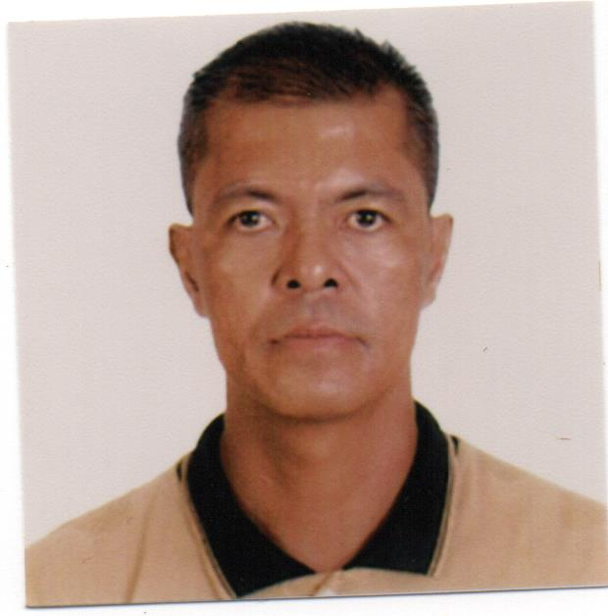
LAURO C. AGUILAR

( ELECTRICIAN )

Permanent Address: 32 M.H. Del Pilar St. San Sebastian, Hagonoy, Bulacan, Philippines
Mobile No. +63917 390 1130 +63939 659 1433
Home No. +6344 321 0242

Summary of Qualification:

More than Twelve (12) years of solid experience as Electrician, that involved Assembly, Installation and Connection of Electrical Wires and Cables.

Specialization:

- Rigid and PVC Pipe Bending
- Layout of Electrical Lines and Circuits

Employment History:

Jun. 2016 – Present | *Driver | Self-Employed
 |  | Hagonoy, Bulacan

Job description:

- Ensure that passengers are transported to their desired destination safely and hassle-free.
- Does regular maintenance of the vehicle and regularly check the vehicle before and after every trip.
- Strictly follow the existing traffic rules and regulations.
- Always in good condition when driving.

Oct. 2015 – May 2016 | *Foreman/Driver | Anore Construction
 |  | Binangonan, Rizal

Project involved with:

Dredging of Guiguinto River

Job description:

- Inform the backhoe operator the exact location of the designated dredge sites.
- Coordinate regularly with the land owners of the designated spoil banks.
- Supervise the day-to-day activities of dredging operations, such as, loading and unloading of dredged materials including the number of trips from the dredging sites to spoil banks.
- Monitor the diesel supply, equipment spare parts, etc. and inform the owner accordingly for purchase.
- Serves as driver during purchase of supplies or construction materials.

Jan. 2009 – Sep. 2015 | *Driver | Self-Employed
 |  | Hagonoy, Bulacan

Job description:

- Ensure that passengers are transported to their desired destination safely and hassle-free.
- Does regular maintenance of the vehicle and regularly check the vehicle before and after every trip.
- Strictly follow the existing traffic rules and regulations.
- Always in good condition when driving.

Mar. 2007 – Oct. 2008 | *Electrical Technician | Alfardan Real Estate Co. L.L.C.
 |  | P. O. Box 9948, Doha, Qatar

Projects involved with:

Alfardan Center ( A 7-Star Office and Apartment Tower )
Maintenance of facilities.

Job description:

- Serves as all-around Electrical Technician in the office and apartment tower of Alfardan Center.
- Does maintenmetance works in AHU-FCU types of aircon.
- Replace and install G.I. pipes, wires and cables, utility boxes, pull boxes, mv panel boards and bms control circuit breaker.
- Install rigid pipes and boxes for fire protection alarm system.
- Prepare ground wires and connect to ground rods by cad welding.
- Install and connect photo cells to lightings.
- Install connection lines from water motor to connection boxes thru float switches of water pumps.

Apr. 2005 – Jul. 2006 | *Trades Helper – Electrician | DG21 Limited Liability Company
 |  | Diego Garcia, British Indian Ocean Territory

Projects involved with:

U.S. Military Bachelors Enlisted Quarters
Maintenance of facilities.

U.S. Military Bachelors Officers Quarters
Maintenance of facilities.

Cold Storage Warehouse
Replacement of Emergency Lights.

T-Site Antenna Facilities
Replacement of Ground Wires.

GEODDS Sites
Replacement of Lightings, G. I. Pipes and Wires.

Job description:

- Replace and install G.I. pipes, wires and cables, utility boxes, pull boxes and panel boards.
- Install rigid pipes and boxes for fire protection alarm system.
- Prepare ground wires and connect to ground rods by cad welding.
- Install and connect photo cells to lightings.
- Install connection lines from water motor to connection boxes thru float switches of water pumps.
- Assemble and install fiber optics main box lines.

Dec. 2003 – Feb. 2004 | *Electrician | KBR (First Kuwaiti Trading & Co., Inc.)
 |  | Camp Anaconda Balad, Iraq

Projects involved with:

U.S. Military Porta Cabin
Installation of new cables and main distribution panel board.

Job description:

- Assemble and connect electrical wires to main switch breaker.
- Undertake the breaking and laying of PVC pipes on walls, ceilings, and floors.
- Undertake the laying and pulling of electrical cables.
- Undertake the pulling and tapping of electrical wires to make new connections.
- Task to put in place and connect switches and lightings.

Nov. 2001 – Nov. 2003 | *Building Electrician | Electrical Subcontractor
 |  | Hagonoy, Bulacan, Philippines

Projects involved with:

Residential Houses located at Hagonoy, Bulacan
Installation of new electrical lines.

Job description:

- Undertake the pulling and tapping of electrical wires to make new connections.
- Undertake the breaking and laying of PVC pipes on walls, ceilings, and floors.
- Assemble and connect electrical wires to main switch breaker.
- Task to put in place and connect switches and lightings.
- Interpret electrical layout plan and data.

Aug. 1999 – Sep. 2001 | *Building Electrician | Al-Madaen Star
 |  | Riyadh, Saudi Arabia

Projects involved with:

Al-Qassim Mosque and Buildings
Installation of new electrical lines.

Al-Kharj Gasoline Station
Renovation and replacement of electrical lines.

Riyadh Mosque
Installation of new electrical lines.

Job description:

- Undertake the breaking and laying of PVC pipes on walls, ceilings, and floors.
- Undertake the laying and pulling of electrical cables.
- Task to put in place and connect switches and lightings.
- Undertake the pulling and tapping of electrical wires to make new connections.
- Assemble and connect electrical wires to main switch breaker.
- Interpret electrical layout plan and data.

Sep. 1997 – Mar. 1999 | *Building Electrician | Self-Employed
 |  | Hagonoy, Bulacan, Philippines

Projects involved with:

Residential Houses located at Hagonoy, Bulacan
Installation of new electrical lines.
Job description:

- Assemble and connect electrical wires to main switch breaker.
- Task to put in place and connect switches and lightings.
- Undertake the breaking and laying of PVC pipes on walls, ceilings, and floors.
- Undertake the pulling and tapping of electrical wires to make new connections.
- Interpret electrical layout plan and data.

Jul. 1996 – Jun 1997 | *Lead Abatement Worker/ Electrician | Department of the Navy,  U. S. Naval Air Facility
 |  | FPO AP 96516 Midway Island, U. S. Territory

Projects involved with:

U.S. Military Galley
Lead and Asbestos Abatement.

U.S. Military Facility
Maintenance of facilities.

U.S. Military Power Plant
Maintenance of facilities.

Job description:

- Assign to abate the lead base paint of 93 buildings in the U.S. Naval Air Facility in Midway Island.
- Undertake the pulling and tapping of electrical wires to make new connections.
- Undertake the breaking and laying of PVC pipes on walls, ceilings, and floors.
- Task to put in place and connect switches and lightings.

Nov. 1990 – Feb. 1996 | *Utility/Dishwasher | KIWI House Restaurant
 |  | 2004 Pasay Road Makati, Philippines

Job description:

- Task to clean the premises and ensure that everything is in proper order.
- Maintain the cleanliness and orderliness in the work area.
- Accomplish other jobs that maybe assigned from time to time.

In-Service Training and Trade Test Undertaken:

- Adult CPR
Diego Garcia, British Indian Ocean Territory
July 15, 2005
Certified By: The American Red Cross

- Standard First Aid
Diego Garcia, British Indian Ocean Territory
July 15, 2005
Certified By: The American Red Cross
- Building Electrician Trade and Evaluation Test
Manila, Philippines
July 28, 1998
Sponsored By: Executive Technical Consultants Trade Test & Training Center, Inc.

- Building Electrician Trade and Evaluation Test
Manila, Philippines
Sponsored By: Diversified Technical Consultants

- Asbestos Abatement Worker Initial Course
Midway Island, Hawaii
February 01-04, 1997
Sponsored By: Professional Services Industries, Inc.

- Lead Abatement Worker Initial Course
Midway Island, Hawaii
October 28-30, 1996
Sponsored By: Meta-Mayhem Environmental Training Associates, Inc.

Educational Attainment:

Vocational : Basic Machine Shop, 1984
Don Bosco Technical College
Manila, Philippines

: Building Wiring Installation, 1986
National Manpower Youth Council
Bulacan, Philippines

Other Skills:

Drafting, Silk-Screen Printing, Plumbing, Carpentry and Masonry. Driving light vehicle including bobcat, fork lift operating machinery includes portable drills, sanding machine and welding.

Personal Data:

Nationality : Filipino
Languages : Filipino / English
Marital status : Married to Shamgar C. Aguilar
Date of Birth : January 22, 1967
Place of Birth : San Sebastian Hagonoy, Bulacan, Philippines
Height : 1.68 m
Weight : 66 kgs.
References : Available upon request

This is to certify that all data written above are true & real to the best of my knowledge and belief.

LAURO C. AGUILAR

