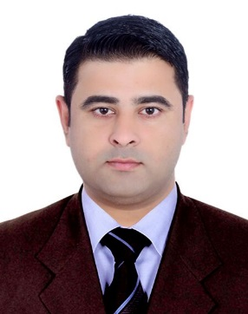
MUHAMMAD IRSHAD
AJMAN (UNITED ARAB EMIRATES)
CELL# (00971) 557088100
Email: Muhammad.irshad000000@gmail.com

PERSONAL SUMMARY
Seeking a Challenging and dynamic career which will utilize my knowledge and abilities. To work in a reputable organization where creativity is accepted besides maximizing my potentials by exploiting present skills and continually developing new ones.
PERSONAL DETAILS
Name : Muhammad Irshad
Name of Father : Muhammad Ismail
Nationality : Pakistani
Date of Birth : 08/09/1989
Marital Status : Single
Passport Details : AU 1912132
Visa Status : Employment / Transferable

ACADEMIC PROFILE
COURSE | BOARD/ UNIVERSITY | YEAR OF PASSING
Matric ( Science) | Board of Intermediate And Secondary Education Mardan | 2005
FSc Pre Medical | Board of Intermediate And Secondary Education Mardan | 2009
Diploma in Health and Safety Environment | Skill Development Council Government of Pakistan | 2010

TECHNICAL QUALIFICATION
- Fireman Course Certificate.
- Leading Fireman Course Certificate.
- Fire Safety Officer Course Certificate.
- Construction Safety Officer Course Certificate.
- Station Fire Officer Course Certificate.
- Computer Office Automation Certificate.
DRIVING LICENSE DETAILS
Driving License # : 164289
Place of issue : Al Fujairah
Date of issue : 09/07/2014
Date of Expiry : 08/07/2024
LANGUAGES KNOWN
- Arabic 2) English 3) Urdu 4) Pashto 5) Hindi
EXPERIENCE
- Presently working in AJ Security and Safety Consultancy Ajman UAE as a Security Guard from 14 January 2012 up to Present.
- Worked with Real Protect Security Pvt (ltd) Company Pakistan as a Security Guard for TWO years from March 2006 to April 2008.
- Worked with Heavy Mechanical Complex Pvt (ltd) company Pakistan as a Fire Supervisor for THREE years and SIX months from June 2008 to December 2011.

PERSONAL SKILLS
- Having a professional attitude.
- Leadership and decision making skill.
- Service oriented and problem solving.
- Willing to work in shifts, morning, night etc.

DECLARATION
I do hereby declare that the above said details are true to the best of my knowledge and belief.

Muhammad Irshad

