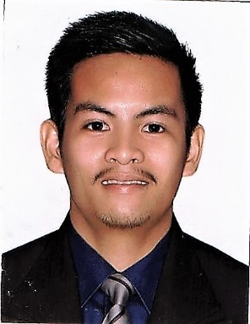
ROLAN S. MALLARI
Purok 4, Antonio Luna Street, Maimpis, City of San Fernando, Pampanga
CELL#: 0935-4362351
Email: roland_mallari07@yahoo.com

PERSONAL BACKGROUND
Birth Date : March 7, 1991
Birth Place : City of San Fernando, Pampanga
Civil Status : Single
Religion : Christian
Citizenship : Filipino
Passport # : P4801659A
Seaman’s Book# : C1153596

WORKING EXPERIENCE

- Company: Coca-Cola FEMSA Philippines
Address: Km72 Mc Arthur High Way San Isidro City of San Fernando Pampanga
Position: Sales Representative (Pre Seller)
Date: September 2013--March 2018
- Achieve the daily and monthly sales targets by ensuring complete and proper coverage of the allocated area; ensure that all outlets are visited in the correct sequence, follow the planned call in each outlet and make sure that they are well stocked with all our brands and packages
- Determine the amount of cases required for next day’s first loading and order the load accordingly.
- Maintain a good relationship with the customers at all times.
- Develop sales and distribution, in liaison with the Sales Supervisor, vertically by identifying and establishing business relationships with new clients and horizontally by introducing the full range of the products to existing clients.
- Submit a daily activity report to the Supervisor detailing the competitors’ activities; complete the route cards, invoices, settlement sheets as well as any other required documents.
- Ensure that shortages, outstandings and collections are settled with the Accounts Department and that cash sales are deposited with the Cashier at the end of the day
- Reflect high standards of performance in implementing the trade promotions and marketing activities that relate to his routes and customers.
- Merchandise the products in the coolers and displays, utilize the Point of Sales (P.O.S.) materials, check the expiry dates in all outlets and rotate stocks whenever required.
- Lead the team of Helpers through constant training and merchandising.
- Ensure proper care and maintenance of Company coolers and report faulty equipment to the Sales Supervisor for remedial action.
- Drive the Company vehicle with extreme care while maintaining a strict code of traffic discipline and safety requirements; daily check the vehicle fluid levels and follow the Company policy with regards to the maintenance and servicing of trucks (which shall not be used for private or personal use).

EDUCATIONAL BACKGROUND

- TERTIARY St. Nicolas College of Business and Technology
Bachelor of Science in Business Administration
MEL-Vi Building, Jose Abad Santos Avenue
Dolores, City of San Fernando, Pampanga
2009 - 2013

CHARACTER REFERENCES

Michelle Q. Villano
Managing Editor of Foreign Post, Inc. (newspaper) and
Proprietor of Orange and Lemon Grill Taft Ave., Manila
www.theforeignpost.info
foreignpost_1016@yahoo.com
027137182
09178892680

Mark Liam
Sales Executive
Coca – Cola FEMSA Philippines, Inc.
09178825481

I hereby certify that above information are true and correct to the best of my knowledge and abilities.

Rolan S. Mallari

