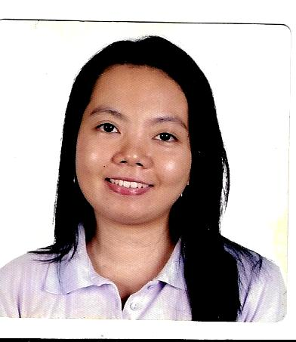

**Yvette V. Lim**

**Adress:** 24 Pearl street Sta Teresita Village Tisa Cebu City 6000 Philippines

**Mobile phone:** **+639231483585**

**Email Adress:** yvetta_28@yahoo.com

**Objective:** to be able to work as Mushroom Picker for the right company where I can provide excellent service to the customers.

**Personal Information:**

Age: 38

Place of Birth: Cebu City

Gender: Female

Citizenship: Filipino

Languages Spoken: English, Tagalog, Visayan

Height: 5 ft.

Weight: 110 lbs.

Skills: Communication & Listening skills, Computer literate, Encoding, Marketing, Multi tasking, Knowledgeable in operating standard office machineries, Knowledge in Microsoft Office Applications

**Education**

**College**

Graduated March 2008

Bachelor of Science in Hotel and Restaurant Management

Southwestern University

Villa Aznar Road Urgello street Cebu City

University of San Carlos Cebu City

Bachelor of Science in Business Administration

Year 1998 – 2001

Cebu Doctors College

Pre – Dentistry

Year 1996 - 1997

**High School**

Graduated: March 1996

St. Theresa’s College

General Maxilom Cebu City

**Elementary**

Graduated: March 1992

St. Theresa’s College

General Maxilom Cebu City

**Work Experience**

**Company: Tech Mahindra Cebu City**

**General Maxilom Cebu City**

**Position: Customer Support Associate**

**Date Employed: August 17, 2015 – 05/26/2017**

**Company: Ameeratel**

**GAGFA Tower Mabolo Cebu**

**Position: Voice Agent Outbound**

**Date Employed: June 15, 2015 – July 20, 2015**

**Company: June Spring Multimedia Cebu**

**Position: Voice Outbound Agent**

**Date Employed: October 2014 – November 2014**

**Company: Cebu Normal University**

**Position: Frontliner Office staff**

**Date Employed: November 19, 2012 – September 29, 2013**

**REFERENCES**

1. Eppie Lao

HR Officer

Cebu Normal University Cebu City

Telephone: +63 (032) 253 – 9611

1. Shiela Esmas

Vice President Operations

June Spring Multimedia

Telephone: +63 (032) 236 – 9039

1. Monique Borja

HR Officer

Ameeratel Philippines

Telephone: +63 (032) 401 - 1505